Hello there,

I am far from being a pro at PVP, but I am fairly used to databases in my real-life work.

All the following started with a simple question on PF2K stream some weeks ago: “how much celt spearmen do we need to one shot a villager?”. He said “I think it’s between 12 and 14” if I remember correctly. **Spoiler alert** he was right you need 13,97 celt spears to one shot a villager without any upgrades or 7 for a two shot.

Since that question I was wondering if we could know this for all combinations of units and buildings in the game. This study started there!

I feel like some information this tool shows can benefit the dev team and the balance team and that is why I made this tool.

His purpose:

Give the number of animations for each damage type you need to kill a unit or a building with or without damaging or defensive upgrades. It can also show the amount of a certain unit you need to one shot something. This tool factors in all the upgrades available in the game.

It also gives the average damage dealt by animation factoring bonus damage, HP, Armor, BdP of the target. It is an average since all animations for the same damage type have an equal chance to occur (except charge attacks applying on the first attack only).

After some tries and discussions with PF2K, Recon and SystemGlitch I added some more information’s like:

* The average time of attacking animations for each damage type.
* The discrepancy between the longest and shortest damage animation.
* Time to kill which is the time of all real animations needed to kill for example if you need 3.1 animation to kill you really need 4. But to be more precise, I subtracted the time after the hit to the end of the last animation. As you know after the attack is done you can move around with the unit.
* Finally, I added a comparison list to compare each stat listed above, for different units on the same target.

We can simulate a lot of stuff by changing the database values and try stuff before patching the game and try in game those fights.

I feel a lot more can be done with that data base.

I try to not display too much since I want it to be readable. I can always add data or sheets to improve this tool. If you have any suggestion for improvements or anything, I will consider them all.

I feel the next important thing I can add is to also display the damage taken while hitting the target. it can already be done but you need to keep those values in mind or copy paste them on a new sheet while you calculate the « reverse research ».

Anything can be added to the database it will automatically be available in the tool if all the cells are completed, this is so helpful to add possible changes and try them out before release. I know my tool is not perfect I will keep updating it.

If you have any questions on how that work or experimenting some bugs feel free to reach me.

Note that you may want to install Ashley font for a better experience. I will showcase with some screenshot the tool for whom cannot open it, sorry I could not do it on another support than excel (at least for now).

After some talks with **PF2K**, I think it is better if this is only for the Celeste Team (devs, mods and balance team). Seeing the balance discussion channel in discord makes me think chaos will emerge if everyone accesses this kind of tool.

# Example:

Let’s take for example lancers champion and you want to know how much you need to kill a villager:

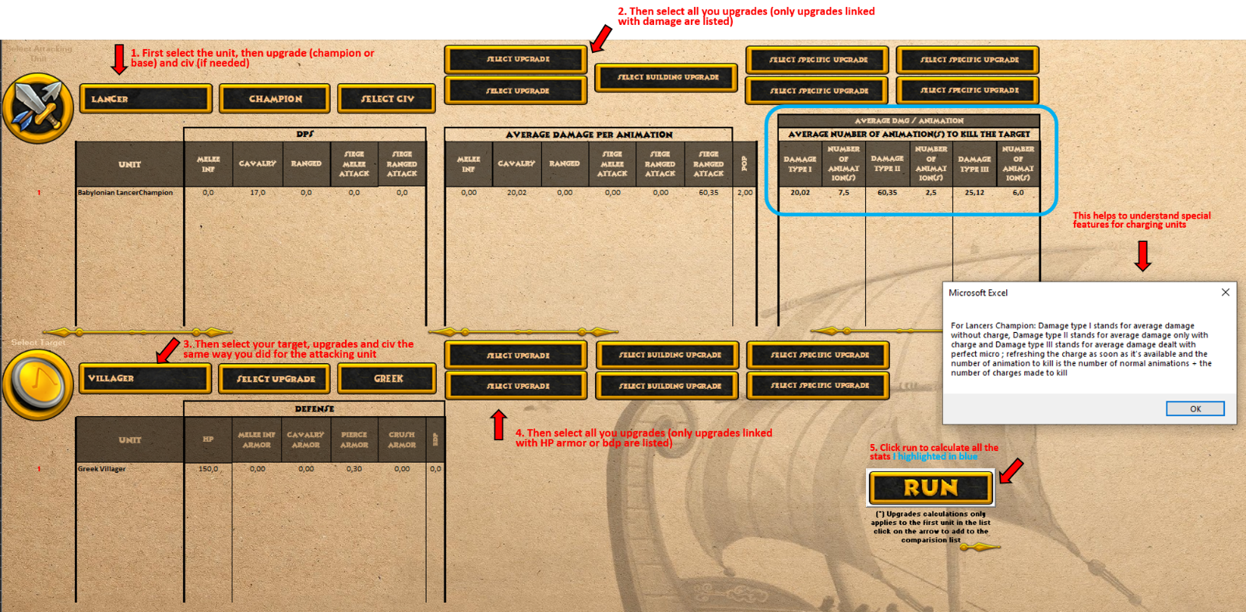

If after that you want to calculate how many you need to kill a house, you can change the target unit from villager to house and click run again to have the information.

Another example, you want to compare all ships targeting a Greek trireme, you do what I did above selecting a ship attacking a Greek trireme, then you click on the arrow next to the run button, then you change the attacking ship and so on, when you have finished, check the comparison list sheet: Une image contenant texte

Special thanks to **PF2K** for your time explaining me how stuff works and helping me fix the 99 problems I got during this. Thanks to **SystemGlitch** for all the data I needed and my numerous questions. Sorry guys for being that noob at this, but in the end, I think it can help the community. Big Thanks to **Recon** too, helping me making a better use of those stats and value for a better tool.

# How it works:

I am sure a lot of you guys know about how it works but I will remind it there to explain my process clearly.

Let's start with some basics. Damage in AoEO is calculated as "damage per second" (=DPS). That means, if a unit attacks slowly (like every 3 seconds), the actual damage is multiplied by the amount of seconds which the attack animation takes (*). You could also count the time between two attacks.

(*) Animation duration is available in offline mode in animation display for each unit.

My first concern was to make database of all the attack animation durations. Some units have a lot of animations, where animation durations may be different, number of hits per animation may be different too. On top of that there are crit animations with different durations too (only for PVE).

All animations have the same probability to happened (except for crit, or charge being the first animation done).

Just to show you how a complex unit is made:

**Immortals** have 5 animations with 2 animations are melee attack, 2 animations are Ranged shots, 1 animation is critical melee animation.

Melee animation number one is 3 hits. (Animation duration = 1.67 sec.)

Melee animation number two is 2 hits. (Animation duration = 1.58 sec.)

Ranged animation number one is 1 hit. (Animation duration = 2.29 sec.)

Ranged animation number two is 1 hit. (Animation duration = 2.67 sec.)

Crit melee animation is 2 hits. (Animation duration = 1.58 sec.)

Crit Ranged animation is not in the game.

I might introduce few terms I used during this study.

True damage = Damage done per animation = DPS x Animation Duration.

Average True Damage = ((DPS x Animation duration1) x (DPS x Animation duration2) x…))/ Number of animations (for the same type of damage). This is an average of dmg done regardless of the animation made.

So, more Mathematics:

Damage per hit = Damage done by one hit or shot from a unit.

Damage per hit = (DPS x Animation Duration) / (Number of hits)

This was my focus on this study, find every true damage on all units. In my opinion as important as DPS to compare units of a certain type, or same unit on different civs. You may ask why? I am sure a lot of PVP players know why, but anyway I am glad you ask:

* Let's refer to Egyptian and Norse spearmen to make an example. Both have the same Damage per second, 10 DPS. But now if you want to kill a villager for example you will try to get more of the Egyptian one since their damage per animation is lower. You will need 12 Norse spearmen to one shot a villager while you will need 17 Egyptian spearmen to do the same. (all those values are for standard stats with no upgrade).
* On the other hand, let’s take Celt Swanship and Egyptian Elephant Archer, but different DPS: 60 DPS for Celt Swanship and 75 DPS for Egyptian Elephant Archer.

Animation durations are: 3.75 seconds for the Swanship and 3 seconds for the Elephant Archer, one animation each:

If we calculate damage per hit in this case = Damage per animation = DPS * animation duration = 60*3,75= 225 and 75*3 =225.

They have the same damage per animation (=225)

Now we let each of them attack an imaginary building (with no pierce Armor to simplify) individually for a specific time frame. I will just choose 60 seconds (1 minute).

But over the course of 60 secs the Swanship will do 3600 damage to the building while elephant archer will do 4500. The difference comes from the different attacking rates.

Now we all know why slow-attacking units are hitting hard and fast-attacking hits so "weak". However, in the long run, however, it balances out.

Now that this is (hopefully) clarified, next, I made the chart of all attack animation durations, number of hits by animation and at what % of the animation the attack is made (I also add this stat converted in seconds at the end of the database). Once all of this was made, I needed to find how to calculate the relation between the attacking unit stats and the ones on a target.

I want to address another chapter for damage calculation on one target: The Armor and Bonus damage Protection (BdP).

I need to factor armor and BdP to the target, so this way we have:

Average Damage dealt per animation = (Damage per animation – (Armor of the target x Damage per animation)) x (Bonus Damage Protection of the Target x Bonus)

There are some units in this game which deal more than one damage type (e. g. Immortals as an example used before). In this case, you just need to calculate the damage output for each type and calculate damage dealt for both cases individually.

I also calculate and display for each damage type:

* Avg Anim Duration: average of animation duration of the same type of damage
  + Important note: I display average values but in fact it is not true, for example a Carpentom need 1,1 animation to kill a Toxote without upgrades but in fact it is more than 1 so it is 2 animations. I thought it might be useful to show real values to make future change to have those averages.
* Moment of attack: the time at which the unit attacks (in seconds)
* Largest discrepancy: discrepancy between the slowest animation and the quickest animation
* Time to kill (in seconds): this one is trickier, but it is the real time to kill the target [ average number of animations required to kill (the real one this time) * average duration of animations-(1- (moment of attack)] * average duration of animations) because you kill before the end of the last animation.

Well, that was a lot of in-depth stuff. I hope that I could make some things clear in this complicated stats and values.

# How to use it:

Now comes the easy part: go and try the tool yourself. All the calculations detailed above are coded, you will have to follow few steps:

Step 1: Select your unit, its upgrade (Champion or Non-Champion) and the Civ

Step 3: Select your Armory attack upgrades, building upgrades and civ specific upgrades.

Step 2: Do the same for your target.

Step 4: Select your Armory Defence upgrades, building upgrades and civ specific upgrades.

Step 5: Press Run to calculate the **average true damage dealt per animation to the target** and **the number of animations you might need to kill it** (check warnings below), or you can see it the other way as this number being **the average number of units you need to one shot the target**.

Step 6: To compare different units you may want to click on the arrow below the run button, to add for the same target all the first attacking unit on the list, change some upgrades or change unit and click it again to compare them easily.

**Warnings:**

Some upgrades are always available even though the unit cannot benefit from it, please select **ONLY** the upgrades the unit or building can access to.

If you have more than one unit or building on the target list. This tool calculates the average true damage dealt per animation **ONLY** to the **Target 1** and the number of animations you might need to kill **Target 1**.

I am sorry, I could not make it in another format that excel’s for now.

You can open this with Microsoft Office, Microsoft Excel, Microsoft Access, OpenOffice (free), LibreOffice (free)and with SoftMaker Office PlanMaker Mobile (free on Android). If you guys know other ways to open .xlsm files, let me know I will add them to the list.

I will be updating this for each balance patches and I will add romans when they will be released. If you experience any kind of bug or strange values, please let me know I will fix them as I go toward a new version of this tool (I hope executable or as a website), but first I need to learn how to code.